Exercise 2

For exercise 2 we had to create a program to encrypt text using a Vigenere cipher. This program was also expected to decrypt the text using the password which encrypted the text. The concept of the Vigenere cipher is that the user creates a password, or key, which is used to encypt the text. For the example in the program we were encrypting the text “newcastleuniversity” with the key “ncl”. In practice this means that we split the text down in to three character substrings of the text (i.e. “new” “cas” “tle” “uni” “ver” “sit” “y”) and shift these characters by the values dictated by the key (these are zero-indexed, something which tripped me up in the development process, meaning that 'a' is equal to a shift of 0, therefore 'c' is 2 and not 3 as I was initially shifting it.) eventually ending up with a text that has been encrypted (Figure 1.).

As mentioned above, the solution to this was to break the plaintext into substrings which were the length of the key and then use the values dictated by the characters of the key to shift the individual letters of this substring. This was a simple concept to get working, and can be seen in the “encrypt” method. Decrypting was the inverse of this, so again was relatively simple and can be found in the “decrypt” method.
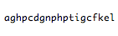Figure 1: Encrypted text.

The complex part of this exercise, then, came with the breaking of the cipher. This was quite difficult in the beginning because, whilst I knew what I wanted to do and how to do it, I couldn't for the life of me figure out the way in which to program the solution. This ended up with me hand writing the solution on a white board and going from there. To break the shift cipher you first need to look for a recurring pattern within the text, this needs to be a pattern that recurs through the ciphertext numerous times (I've set it as 3 or more), this is called the Index of Coincidence and, suitably, my method for this is called “coinc” (Figure 2.). The way in which this method works is that it looks for 3 character patterns within the ciphertext. Initially the pattern it looks for is the first 3 characters in the text, if this returns less than three locations (the points in the array where the pattern starts) then the pattern changes to be the character sequence from character 2 to 4, then 3 to 5 and so on, until the point where the number of locations is greater than 2 (note: the locations returned have the first location removed from them, so the first location could be 5 but appears to be 0, and all subsequent locations are the location – 5; this will be explained later).

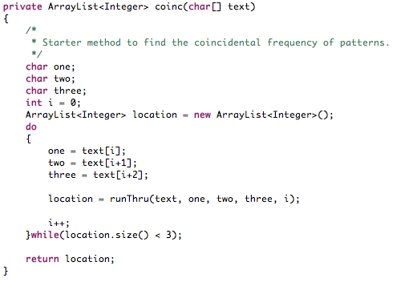Figure 2: Method for obtaining the index of coincidence.
This method returns an ArrayList of integers, which correspond to the location of the pattern, minus the first pattern. This is integral for the next stage in the process which is finding the key length. Removing the first location's value from each location means that what is returned in the ArrayList is not the locations but the distance between the first found pattern and the subsequently found patterns. These values are then passed into a function to find the greatest common divisor of all of these values, which should return the length of the key (which, in the case of the given ciphertext, is 5).This works because the GCD of each of these distances will be at the least, a multiple of the key. Once the length of the key has been discovered, we then move on to the next stage which is a frequency analysis of the separate sections of the ciphertext. Essentially, because of how the encryption works, the rest of the decryption is the same as the shift cipher, it's just that the Strings which we're using will be made up of the relative values in their substrings (i.e. In our example we'll have 5 Strings, one for each index in the key). This was the part I found most difficult because of how to store the information I needed, and for it to be mutable for various lengths of key. This ended up with me creating a String array to store the multiple strings, using the method “brDwn” (Figure 3.). After the Strings were broken down, I ran each of them through the methods I copied from my Shift Cipher decryption program from exercise 1 to obtain the value to shift for each String. This shift value then equates to the character in the alphabet. Adding the values together reveals the key to be “plato” and allows for the deciphering of the ciphertext when both key and text are passed to my “decrypt” function (Figure 4.).

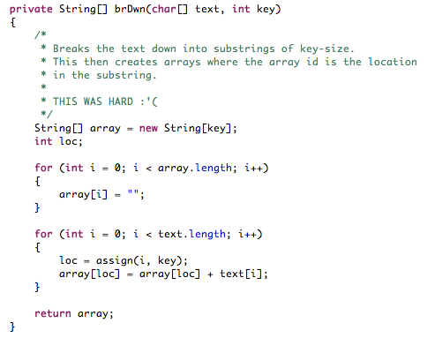Figure 3: The brDwn method to break the ciphertext into x number of indexed substrings.
Figure 4: Obtained key (top) and decrypted ciphertext.

